INTRODUCTION TO SQL ASSIGNMENTS
Nairobi Academy is a secondary school in Nairobi.
Instructions: You are the new database administrator for Greenwood Academy, a secondary school in Nairobi. Your job is to build the school database from scratch and start querying it.
The Schema
Schema name: nairobi_academy
The Three Tables
Table1: students
Stores information about each student enrolled at the school.
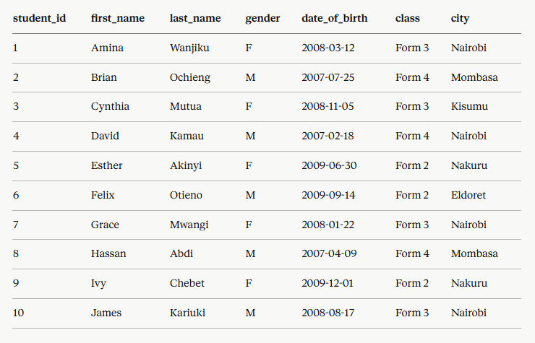

Table2: subjects
- Stores information about each subject offered at the school.

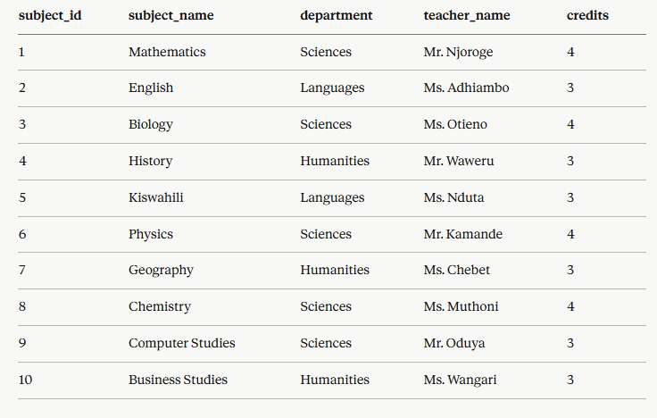

Table3: exam_results
- Records each student’s exam result for each subject
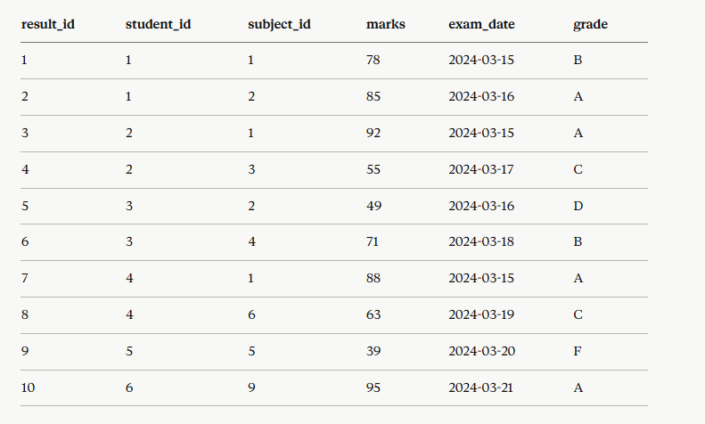

QUESTIONS
SECTIONA – Building the Database (DDL)
Q1. Create a schema called nairobi_academy and make sure SQL is using it before you do anything else.
Q2. Create the students table with the following columns:
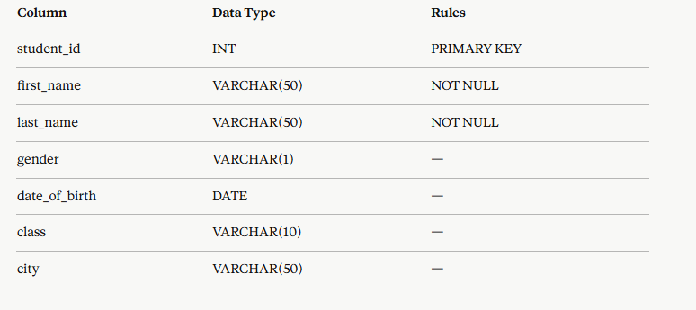

Q3. Create the subjects table with the following columns:
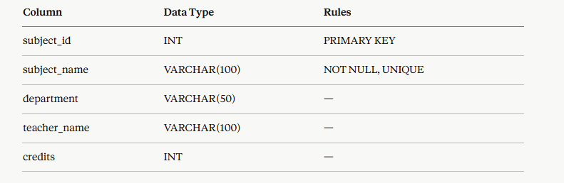

Q4. Create the exam_results table with the following columns:
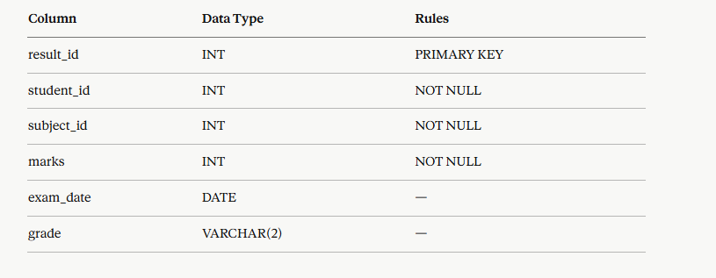

Q5. After creating the students table, the school realises they forgot to include a phone number column. Use ALTER TABLE to add a column called phone_number with data type VARCHAR(20).
Q6. The column credits in the subjects table needs to be renamed to credit_hours. Write the SQL to rename it.
Q7. The school decides they no longer need the phone_number column you added in Q5. Write the SQL to remove it completely from the students table.

SECTION B - Filling the Database (DML: INSERT, UPDATE, DELETE)
Q8. Insert all 10 students into the students table
Q9. Insert all 10 subjects into the subjects table.
Q10. Insert all 10 exam results into the exam_results table
Q11. After inserting the data, run a SELECT query to confirm all 10 rows exist in each of the three tables.
Q12. Esther Akinyi has moved from Nakuru to Nairobi. Write an UPDATE statement to change her city. (Her student_id is 5)
Q13. The marks for result_id 5 were entered incorrectly - the correct marks are 59, not 49. Write an UPDATE to fix this.
Q14. The exam result with result_id 9 has been cancelled by the school. Write a DELETE statement to remove it from the exam_results table.

SECTION C Querying the Data (Filtering with WHERE)
Q15. Write a query to find all students who are in Form 4.
Q16. Write a query to find all subjects in the Sciences department.
Q17. Write a query to find all exam results where the marks are greater than or equal to 70.
Q18. Write a query to find all female students only. (Hint: gender = 'F')
Q19. Write a query to find all students who are in Form 3 AND from Nairobi.
Q20. Write a query to find all students who are in Form 2 OR Form 4.

PART2 - BETWEEN, IN/NOT IN, LIKE, COUNT, and CASE WHEN
SECTION A - Range, Membership & Search Operators
Q1. Write a query to find all exam results where marks are between 50 and 80 (inclusive).
Q2. Write a query to find all exams that took place between 15th March 2024 and 18th March 2024.
Q3. Write a query to find all students who live in Nairobi, Mombasa, or Kisumu - use IN.
Q4. Write a query to find all students who are NOT in Form 2 or Form 3 - use NOT IN.
Q5. Write a query to find all students whose first name starts with the letter 'A' or 'E' - use LIKE.
Q6. Write a query to find all subjects whose subject name contains the word 'Studies'.

SECTION B - COUNT
Q7. How many students are currently in Form 3? Write the query.
Q8. How many exam results have a mark of 70 or above? Write the query.

SECTION C - CASE WHEN
Q9. Write a query using CASE WHEN to label each exam result with a grade description:
- 'Distinction' if marks >= 80
- 'Merit' if marks >= 60
- 'Pass' if marks >= 40
- 'Fail' if marks below 40
Call the new column performance.
Q10. Write a query using CASE WHEN to label each student as:
- 'Senior' if they are in Form 3 or Form 4
- 'Junior' if they are in Form 2 or Form 1
Call the new column student_level. Show the student's first name, last name, class, and student_level in your result.

Reminders Before You Start
- Every SQL statement must end with a semicolon ( ; )
- Text values must always be in single quotes - 'Nairobi'
- Numbers do NOT need quotes - WHERE marks > 70
- Always use WHERE with UPDATE and DELETE - without it, every row gets affected
- Dates are written as 'YYYY-MM-DD' - e.g. '2024-03-15'
- BETWEEN is inclusive - BETWEEN 50 AND 80 includes 50 and 80 themselves
- IN uses brackets and commas - IN ('Nairobi', 'Mombasa')
- LIKE patterns - 'A%' starts with A, '%Studies%' contains Studies
- CASE WHEN always ends with END - don't forget it!
- Give your CASE WHEN result a name using AS

